SUPREME WARRIOR CHALLENGE
ENTRY FORM

AUGUST 8th 2026
SISK MEMORIAL BAPTIST CHURCH
115 MASSEY STREET FORT MILL, SC 29715
ELIMINATION: Registration begins at 8:00am until your division begins. Tournament begins at 9:00am SHARP with Breaking & Self-Defense. Followed by all 17 & under Color Belts & Black Belt Musicals, Traditional Weapons, Traditional Forms, Open Weapons, Open Forms & Sparing, including Handicap Division. 18+ Divisions will begin in the same order as the Junior Divisions above. Adult Black Belts will compete last.
EQUIPMENT: Foam dipped equipment, feet & headgear, groin cups, mouth pieces and Gi are mandatory.
ARBITRATOR: to be announced CO-ORDINATORS: to be announced
RECOGNITION: Sanctioned by AKANA, American Freestyle Karate. (AKANA rules apply).
Please train accordingly.

FOR MORE INFORMATION: Kyoshi Charles Lingerfelt peacefulwarrior@comporium.net 803.417.4976

(Please remove ‘entry form 2026’ on attached form)
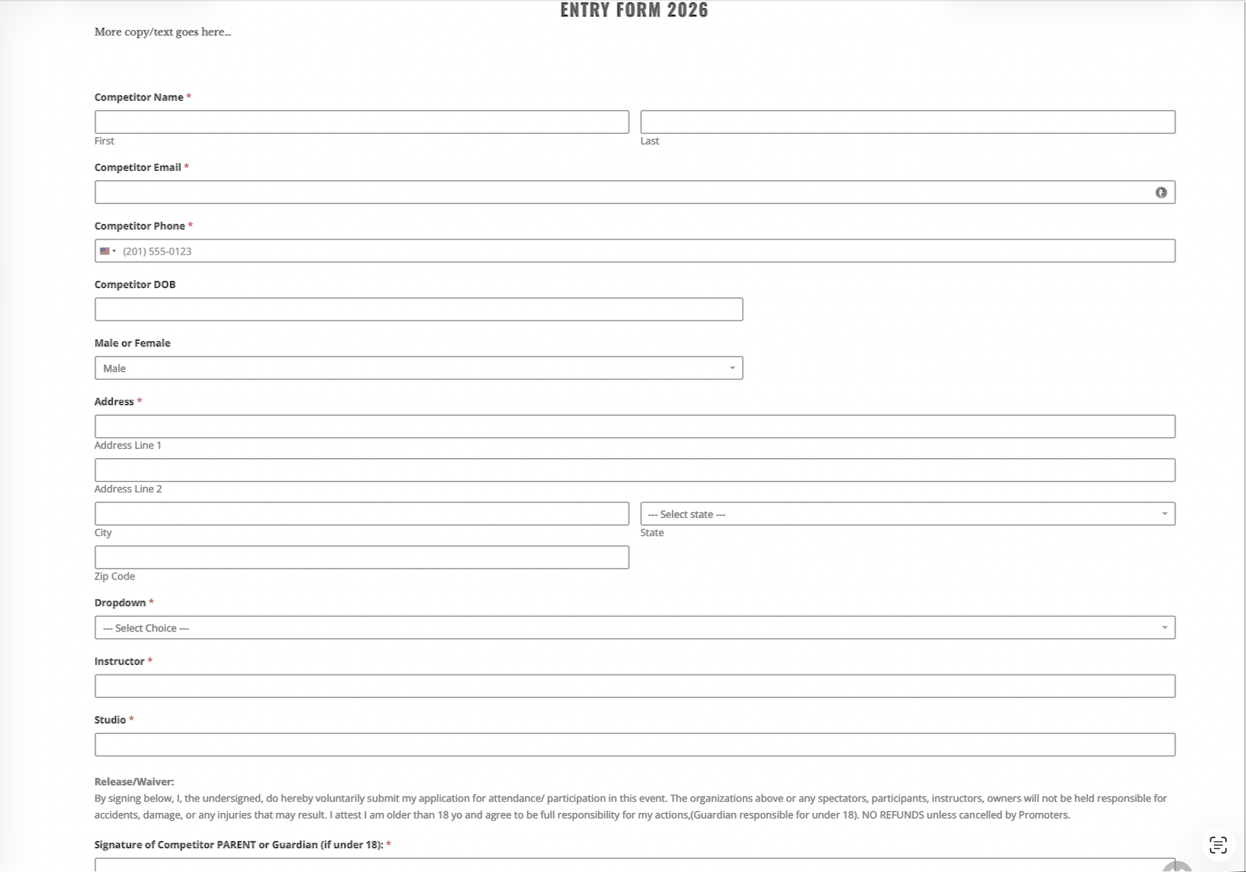
(Please add space at bottom for competitor/parent signature)
*****Pre-Registration (received on or prior to August 01, 2026 – Payment & Form completed)
1 Event $75.00____ or 2 @ $125.00____ + $50.00 each additional =$____ + spectator @ $10.00 each = $____
VIP Seating $30.00 per x ____ = $____ + **Coach@ $25.00____= TOTAL $________ PayPal, Venmo, Credit Card
*****Registration after August 01, 2026
1 Event $100.00____ or 2 @ $150.00____ + $50.00 each additional =$____ + spectator @ $20.00 each = $____
VIP Seating $50.00 per x ____ = $____ + **Coach@ $40.00____= TOTAL $________ (PayPal, Venmo, Credit Card)
*****Coach’s Pass – Must Have to Coach. 1 Coach per match. (In addition to Spectator Fee).

